**Step 1 : Observe the directory Before creation of container**

ls -l /var/lib/docker/containers/



**Step 2 : Deploy a Ubuntu server container**

docker run -itd --name container1 ubuntu:14.04 /bin/bash

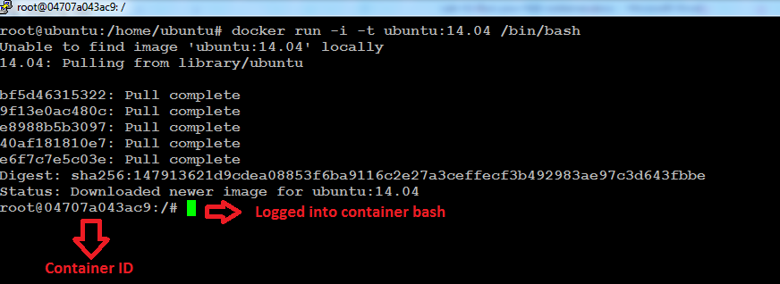

**Step 2.A : list the running container**

docker ps

**docker run – create a continer**

**docker exec – ssh to container**

**Step 2.b : Login to the container**

docker exec -it container1 /bin/bash

**Step 2.C : list process running in container**

root@04707a043ac9:/# ps -ef

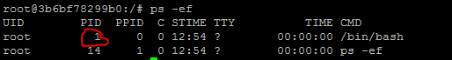

**Step 2.D : list the directory structure**

root@04707a043ac9:/# ls -l

**Step 2.D : check the kernel**

root@04707a043ac9:/# uname -r

**Step 3 : exit from the container**

root@04707a043ac9:/# exit

**Step 4 : Observe the directory After creation of container on docker host login**

ls -l /var/lib/docker/containers/

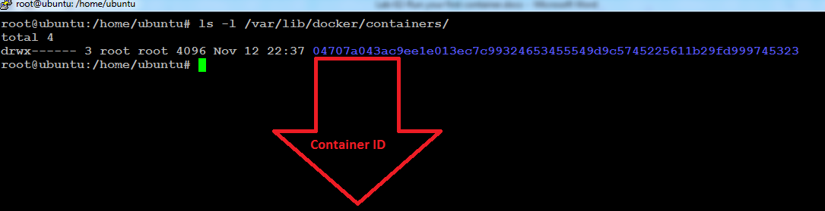

**Step 5 : Listing the Docker images**

docker images



**Step 7 : Fetch info about container**

docker inspect container1

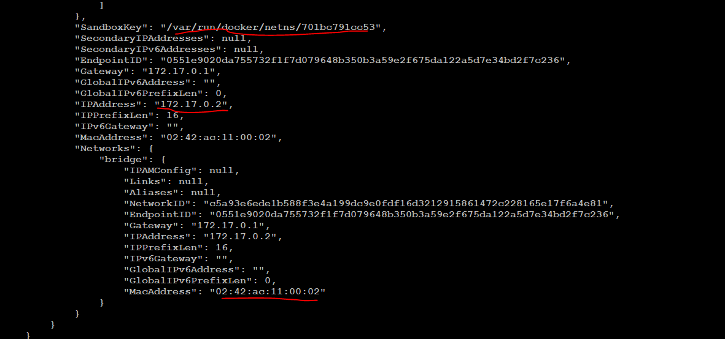

**Step 8 : Login to your container**

docker exec -it container1 /bin/bash

**If you successful login you should be in your container bash login as below**

apt update

apt-get install net-tools -y

**Step 9 : Validate your IP address of container**

root@04707a043ac9:/# ifconfig



**Exiting the container**

root@04707a043ac9:/# exit